Natural Numbers N = { 1, 2, 3, 4 ,5, ….}

Whole Numbers W = { 0, 1, 2, 3, 4 , 5, ….}

Integers Z = { -4, -3, -2, -1, 0, 1, 2, 3, 4 }

Rational Number: { -5, -4, 13/4, -1, 0, 1/8, 1, 2/3, 2, 7/3, …}

IRRational Number: 

Real Number:



* The Real Numbers are  Uncountable
* The set of all Java programs is  countable.
* The set of positive integers (Z+) is called  countable. A set that is not countable is uncountable.
* The set of all finite strings over the alphabet of  lowercase letters is countable.
* The set of real numbers R  is an uncountable set.

 the set of positive even integers is  countable set.

Because of one to one or onto relationship.

* The sum of first n even natural numbers can be calculated as

S=2+4+6+.....+(2n)=n(n+1)

* The sum of first n even natural numbers can be calculated as N2

**SET THEORY:-**

**Number of Subsets of a given Set:**

If a set contains ‘n’ elements, then the number of subsets of the set is 2N.

**Number of Proper Subsets of the Set:**

If a set contains ‘n’ elements, then the number of proper subsets of the set is 2n– 1

For Ex: If A = {p, q} the proper subsets of A are [{ }, {p}, {q}]

**Symmetric Difference:-**

Let A and B are two sets. The symmetric difference of two sets A and B is the set (A – B) ∪ (B – A) and is denoted by A △ B.

Thus, A △ B = (A – B) ∪ (B – A) = {x : x ∉ A ∩ B}

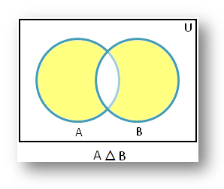

1.R, a relation in a set X, is reflexive if and only if ∀x∈X, xRx.

2.R is symmetric if and only if ∀x,y∈X, xRy => yRx.

3.R is transitive if and only if ∀x,y,z∈X, xRy∧yRz ==> xRz.

**EQUIVALENCE RELATION:-**

An equivalence relation is a relation that is reflexive, symmetric, and transitive.

If two elements are related by some equivalence relation, we will say that they are equivalent (under that relation).

**RECURRENCE RELATIONS:-**

**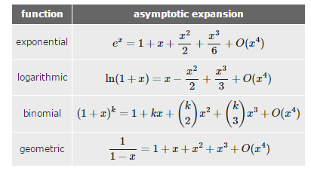**

**GRAPH THEORY**

**Complete Graph**

A complete graph has an edge between any two vertices. You can get an edge by picking any two vertices.

So if there are n vertices = n(n−1)/2 Edges

Complete graph of order n and is denoted by Kn. A graph of order n with no edges is called an empty graph and is denoted by Kn with top underline..

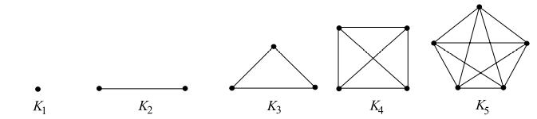

**Connected Graph**

A connected graph is any graph where there's a path between every pair of vertices in the graph.

**Spanning Tree**

A spanning tree is a subset of Graph G, which has all the vertices covered with minimum possible number of edges

How many spanning tree can we derive using n vertices graph.

Ans :According to Cayley formula n pow(n−2).

How many bipartite tree can we derive using n vertices graph.

**Minimum Spanning Tree:-**

A minimum spanning tree is a spanning tree in which the sum of the weight of the edges is as minimum as possible.

It is found using the following algorithms: 1. Prim's Algorithm 2. Kruskal's Algorithm

**Bipartite Graphs**

A bipartite graph is a graph whose vertex-set can be split into two sets in such a way that each edge of the graph joins a vertex in first set to a vertex in second set.

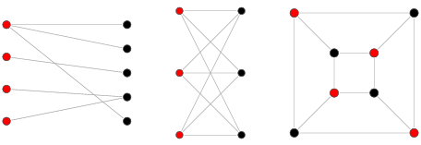

**Complete Bipartite Graph**

A complete bipartite graph is a bipartite graph in which each vertex in the first set is joined to each vertex in the second set by exactly one edge. The complete bipartite graph with r vertices and 3 vertices is denoted by Kr,3.

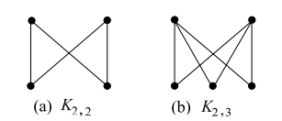

**Hamiltonian Graph:-**

In the mathematical field of graph theory, a Hamiltonian path (or traceable path) is a path in an undirected or directed graph that visits each vertex exactly once. A Hamiltonian cycle (or Hamiltonian circuit) is a Hamiltonian path that is a cycle.

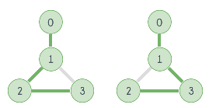

**Euler Graph**

A closed walk in a graph G containing all the edges of G is called an Euler line in G. A graph containing an Euler line is called an Euler graph.

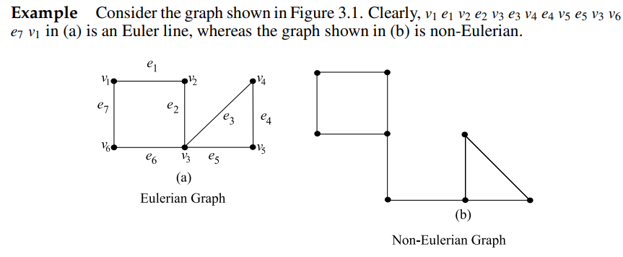

**General Points about Euler and Hamiltonian circuit:-**

\*) A connected graph G is an Euler graph if and only if all vertices of G are of even degree. For example Below picture

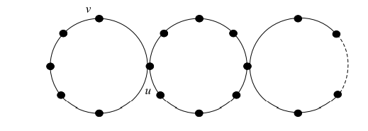

\*) A Hamiltonian cycle visits each vertex of the graph exactly once. But Eulerian circuit traverses each edge exactly once without regard to how many times a given vertex is visited. See below fig

\*) The complete bipartite graph K2,4 is Eulerian but not Hamiltonian. (see below fig)

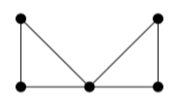

\*) It's easy to find an Eulerian circuit, but there is no Hamiltonian cycle because the center vertex is the only way one can get from the left triangle to the right. (In the above graph)

**Planar and Non-Planar Graphs**

A Graph is planar since no link is overlapping with another.

A Graph is non-planar since many links are overlapping.

Also, the links of graph cannot be reconfigured in a manner that would make it planar.

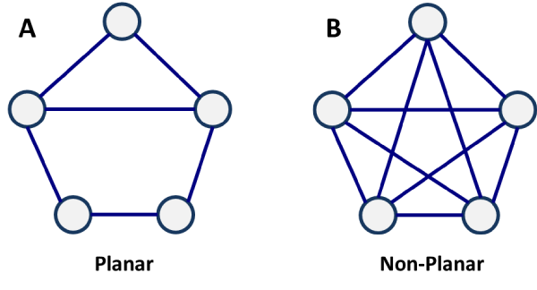

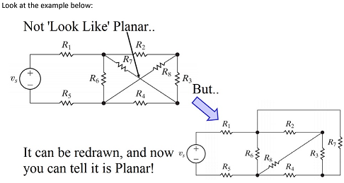

**ISOMORPHIC GRAPH:-**

If two graphs are isomorphic, they must have:

- the same number of vertices

- the same number of edges

- the same degrees for corresponding vertices

- the same number of connected components

- the same number of loops

- the same number of parallel edges.

- both graphs are connected or both graphs are not connected, and

- pairs of connected vertices must have the corresponding pair of vertices connected.

**Example 1 :-**

**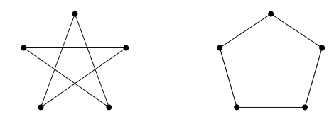**

Firstly, label the graphs. It “looks” true, so check all the things we know:

Number of vertices: both 5.

Number of edges: both 5.

Degrees of corresponding vertices: all degree 2.

Connectedness: Each is fully connected.

Number of connected components: Both 1.

Pairs of connected vertices: All correspond.

Number of loops: 0.

Number of parallel edges: 0.

Everything is equal and so the graphs are isomorphic.

**Example2:-**

No. The left-hand graph has 5 edges; the right hand graph has 6 edges.

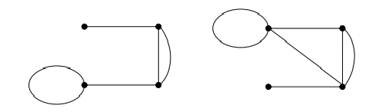

**Euler Circuit in a Directed Graph:-**

[Eulerian Path](http://en.wikipedia.org/wiki/Eulerian_path) is a path in graph that visits every edge exactly once. Eulerian Circuit is an Eulerian Path which starts and ends on the same vertex.

A graph is said to be eulerian if it has eulerian cycle. We have discussed [eulerian circuit for an undirected graph](https://www.geeksforgeeks.org/eulerian-path-and-circuit/" \t "_blank). In this post, same is discussed for a directed graph.

For example, the following graph has eulerian cycle as {1, 0, 3, 4, 0, 2, 1}  
[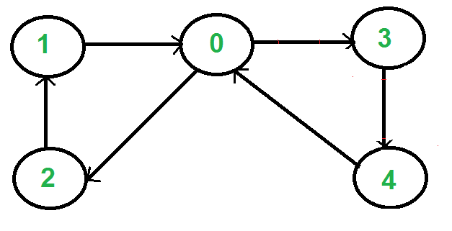](https://www.geeksforgeeks.org/wp-content/uploads/SCC1.png)

How to check if a directed graph is eulerian?  
A directed graph has an eulerian cycle if following conditions are true   
1) All vertices with non zero degree belong to a single [strongly connected omponent](https://www.geeksforgeeks.org/strongly-connected-components/).  
2) In degree and out degree of every vertex is same.

**Eccentricity of a Vertex:-**

The maximum distance between a vertex to all other vertices is considered as the eccentricity of vertex.

**Tautology** :-

A tautology is a formula which is "always true" --- that is, it is true for every assignment of truth values to its simple components. You can think of a tautology as a rule of logic.

**Contradiction**:-

The opposite of a tautology is a contradiction, a formula which is "always false". In other words, a contradiction is false for every assignment of truth values to its simple components.

**NOTE:-**

\*) A -> B is equivalent to ~A V B now checking option A

**Conjunctive and Disjunctive Normal Forms:-**

A Boolean expression is in disjunctive normal form if it is expressed as the sum (OR) of products (AND).

A Boolean expression is in conjunctive normal form if it is expressed as the product (AND) of sums (OR).

A statement is in conjunctive normal form if it is a conjunction (sequence of ANDs) consisting of one or more conjuncts, each of which is a disjunction (OR) of one or more literals

**Normal Forms :-**

Remember that we also called “or” “disjunction” and “and” “conjunction”.

A clause that contains only ∨ is called a disjunctive clause and only ∧ is called a conjunctive clause.

Negation is allowed, but only directly on variables.

P ∨ ¬q ∨ r: a disjunctive clause

¬p ∧ q ∧ ¬r: a conjunctive clause

¬p ∧ ¬q ∨ r: neither

If we put a bunch of disjunctive clauses together with ∧, it is called conjunctive normal form.

For example: (p∨r)∧(¬q∨¬r)∧q is in conjunctive normal form.

Similarly, putting conjunctive clauses together with ∨, it is called disjunctive normal form.

For example: ( p ∧ ¬q ∧ r ) ∨ ( ¬q ∧ ¬r ) is in disjunctive normal form.

**More examples:**

( p ∧ q ∧ ¬r ∧ s) ∨ ( ¬q ∧ s ) ∨ ( p ∧ s) is in disjunctive normal form.

( p ∨ q ∨ ¬r ∨ s ) ∧ ( ¬q ∨ s ) ∧ ¬s is in conjunctive normal form.

( p ∨ r ) ∧ ( q ∧ ( p ∨ ¬q )) is not in a normal form.

¬p ∨ q ∨ r and ¬p ∧ q ∧ r are in both normal forms.

**Predicate Logic:-** Predicate logic is the general form of all logics that uses predicates, like q(x). Here q is predicate. Predicate logic supports the ability to have variables, and quantifiers. For example, ∀x∃y.p(x,y) means "For all x there exists a y such that the proposition p(x,y) is true".

**Propositional Logic:**- Propositional logic means without ability to do predication. For example, in P ^ Q, both p and q are propositions.

**EXAMPLES:-**

Everyone likes someone

(Ax)(Ey)likes(x,y)

Someone is liked by everyone

(Ey)(Ax)likes(x,y)

Every gardener likes the sun.

(Ax) gardener(x) => likes(x,Sun)

You can fool some of the people all of the time

(Ex)(At) (person(x) ^ time(t)) => can-be-fooled(x,t)

You can fool all of the people some of the time.

(Ax)(Et) (person(x) ^ time(t) => can-be-fooled(x,t)

All purple mushrooms are poisonous.

(Ax) (mushroom(x) ^ purple(x)) =>poisonous(x)

No purple mushroom is poisonous.

~(Ex) purple(x) ^ mushroom(x) ^ poisonous(x)

(Ax) (mushroom(x) ^ purple(x)) => ~poisonous(x)

There are exactly two purple mushrooms.

(Ex)(Ey) mushroom(x) ^ purple(x) ^ mushroom(y) ^ purple(y) ^ ~(x=y) ^ (Az) (mushroom(z) ^ purple(z)) => ((x=z) v (y=z))

Deb is not tall.

~tall(Deb)

**PERMUTATION AND COMBINATION**

Lot of problems available in this link

<https://gradestack.com/CBSE-Class-11th-Science/Permutations-and/Extra-Questions/17571-3565-31187-revise-wtw>

**DOMAIN AND RANGE**

The domain is all the x-values, and the range is all the y-values.

For example,

State the domain and range of the following relation?

{(2, –3), (4, 6), (3, –1), (6, 6), (2, 3)}

Ans:- domain: {2, 3, 4, 6} range: {–3, –1, 3, 6}

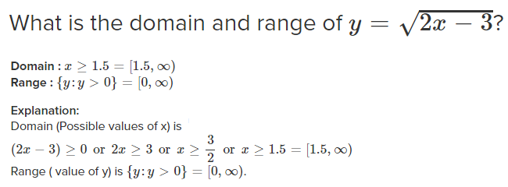

When finding the domain, remember:-

The denominator (bottom) of a fraction cannot be zero

The number under a square root sign must be positive in this section

**GROUP AXIOMS:-**

A group is a set, G, together with an operation • (called the group law of G) that combines any two elementsa and b to form another element, denoted a • b or ab. To qualify as a group, the set and operation, (G, •), must satisfy four requirements known as the group axioms:[5]

**Closure**

For all a, b in G, the result of the operation, a • b, is also in G.b[›]

**Associativity**

For all a, b and c in G, (a • b) • c = a • (b • c).

**Identity element**

There exists an element e in G such that, for every element a in G, the equation e • a = a • e = a holds. Such an element is unique (see below), and thus one speaks of the identity element.

**Inverse element**

For each a in G, there exists an element b in G, commonly denoted a−1 (or −a, if the operation is denoted "+"), such that a • b = b • a = e, where e is the identity element

**Abelian Group added**

Commutativity.a • b = b • a

**QUESTIONS AND ANSWER**

**QUES:-How many edges are there in a forest of t-trees containing a total of n vertices?**

(A) n+t (B) n-t(yes) (C) n\*t (D) nt

**Explanation** : In each tree we have k-1 edges for k vertices.

***QUES:- What is the probability that a randomly selected bit string of length 10 is a palindrome?***

(A) 1/64 (B) 1/32 (Ans) (C) 1/8 (D) 1/4

**Explanation:**

select 10 bits and with every bit we have two choice either 0 or 1 so the total no of 10 length bit strings are 2^10.

now in palindrome if we chose first 5 bits then our job is done as next 5 are fixed ( first 5 in reverse order).

So, for five bits can be chosen in 25 (for every bit either 0 or 1).

Probability = 2^5/2^10= 1/ 32.

***The number of eight-bit strings beginning with either 111 or 101 is .***

(A) 64(yes) (B) 128 (C) 265 (D) None of the above

***QUES:- A box contains six red balls and four green balls. Four balls are selected at random from the box. What is the probability that two of the selected balls are red and two are green***?

(A) 3/7(Ans) (B) 4/7 (C) 5/7 (D) 6/7

**Explanation:-**C(6,2)C(4,2)/C(10,4)

***QUES:- There is a club consisting of six distinct men and seven distinct women. How many ways can we select a committee of three men and four women?***

**Answer:-**There are "6-choose-3" = (6c3) ways to select the men, and "7-choose-4" =(7c4) ways to select the women.

That's because = (6c3) \* (7c4)

***QUES:- A committee of 5 persons is to be formed from 6 men and 4 women. In how many ways can this be done when at least 2 women are included?***

**Answer:-** Here it says atleast 2 women, which in other words mean, the committee may comprise of 2 women and 3 men or 3 women and 2 men or 4 women and 1 man.

Therefore the answer should be 4C2\*6C3 + 4C3\*6C2 + 4C4\*6C1 = 6\*20 + 4\*15 + 1\*6 = 186

Now lets see why the answer should not be 4C2\*8C3 = 6\*56 = 336

You have to make cases for this question.

Total men available=6

Total women available =4

Condition atleast two women.

Case I: 2 women 3 men. This can be done in 4c2 x 6c3

Case II: 3 women 2 men. This can be done in 4c3 x 6c2

Case III: 4 women 1 men. This can be done in 4c4 x 6c1

***QUES:-Skolmization is the process of***

(A) bringing all the quantifiers in the beginning of a formula in FDL.

(B) removing all the universal quantifiers.

(C) removing all the existential quantifiers.(yes)

(D) all of the above.

***QUES:- Consider a set A = {1, 2, 3, …….., 1000}. How many members of A shall be divisible by 3 or by 5 or by both 3 and 5 ?***

(A) 533 (B) 599 (C) 467(yes) (D) 66

**Explanation:-**

(A U B ) = (A) + (B) - (A ∩ B)

A=1000/3 = 333 [No's divisible by 3]

B=1000/5=200 [No's divisible by 5]

A ∩ B= 1000/15=66 [No's divisible by both 3 and 5]

A U B = 333+200-66=533-66=467

***A graph is non-planar if and only if it contains a subgraph homeomorphic to***

(A) K3,2 or K5 (B) K3,3 and K6 (C) K3,3 or K5(yes) (D) K2,3 and K5

**Explanation:-**

Kuratowski’s Theorem: A graph is non-planar if and only if it contains a subgraph that is homeomorphic to either K5 or K3,3

***The proposition ~ p V q is equivalent to***

(A) p --> q (yes) (B) q --> p (C) p <--> q (D) p V q

Explanation: p--> q = ~p V q

***Find the number of ways to paint 12 offices so that 3 of them will be green, 2 of them pink, 2 of them yellow and the rest ones white.***

(A) 55,440 (B) 1,66,320(YES) (C) 4.790E+08 (D) 39,91,680

**Explanation:-** Total number of ways 12 offices can be painted = 12!

But 3 of them will be green, 2 of them pink, 2 of them yellow and 5 of them white.Answer = 12! /(3!\* 2 ! \* 2! \* 5!) = 166320

***How many distinguishable permutations of the letters BANANA are there***

A)720 B)120 C)60 D)360

Number of permutation of n objects with n1 identical objects of type 1,

n2 identical objects of type 2, ......

and nk identical objects of type k is n! / (n1!n2!....nk!)

Permutation of letter BANANA are 6! / (3!2!) = 60

***A test contains 100 true/false questions. How many different ways can a student answer the questions on the test, if the answer may be left blank also.***

(A) 100P2 (B) 100C2 (C) 2100 (D) 3100(yes)

***How many edges must be removed to produce the spanning forest of a graph with N vertices, M edges and C connected components?***

(A) M+N–C (B) M–N–C (C) M–N+C(yes) (D) M+N+C

**Explanation:-**

For an spanning forest of a graph with N vertices and C connected components, No of edges should be E = (N-C), but the given graph contains M edges .. So to have spanning forest no of edges to be removed = M- (N-C) = M - N + C

***Which of the following connected simple graph has exactly one spanning tree?***

(A) Complete graph (B) Hamiltonian graph (C) Euler graph (D) None of the above(yes)

***A recursive function h, is defined as follows :***

***h(m) = k, if m = 0***

***= 1, if m = 1***

***= 2 h(m – 1) + 4h(m – 2), if m ≥ 2***

***If the value of h(4) is 88 then the value of k is :***

(1) 0 (2) 1 (3) 2(yes) (4) –1

**Explanation:-**

h(2)=2h(1)+4h(0) =2+4k

h(3)= 2h(2)+4h(1) = 4+8k+4 = 8+8k

h(4)= 2h(3)+4h(2) = 16+16k+8+16k= 32k+24 =88

32k=64

k=2

***The proposition ~ q ∨ p is equivalent to :***

1. p->q (ans)

***58 lamps are to be connected to a single electric outlet by using an extension board each of which has four outlets.The number of extension boards needed to connect all the light is?***

We can connect 4 Lamps to first extension

Number of Extension required for Remaining 54 lamps = 54/3 = 18 Extension

Total Extension required to connect all 58 Lamps = 18 + 1 =19

***Domain and Range of the function Y = –√(–2x + 3) is***

(A) x≥3/2, y≥0 (B) x>3/2, y≤0

(C) x≥3/2, y≤0 (D) x≤3/2, y≤0(YES)

***How many solutions are there to the equation x1+x2+x3+x4 = 21 where x1 , x2 , x3 , and x4 are nonnegative integers?***

ANS:-

r = 21, n = 4, so we have C(21+4-1, 21) = C(24, 21) = 2,024 solutions

***How many solutions are there to the equation x+y+z=17 ?They are non-negative integers.***

A) 120 B)171 C)180 D)121

Ans:-

No. of solutions to the equation x+y+z=17 is given by formula

C(n+r-1, n-1) = C(3+17-1, 3-1) = C(19,2) = 171

Ans (B)

***How many multiples of 6 are there between the following pairs of numbers? 0 and 100 and –6 and 34***

(A) 16 and 6 (B) 17 and 6 (C) 17 and 7 (D) 16 and 7

Answer: (C)

Explanation: Between 0 and 100 multiple of 6 are: 0,6, 12, 18, 24, 30, 36, 42, 48, 54, 60, 66, 72, 78, 84, 90, 96 ie. 17 multiple.

Between -6 and 34 multiple of 6 are: -6, 0, 6, 12, 18, 24, 30. ie. 7 multiple.

So,option (C) is correct.

***The number of different spanning trees in complete graph, K4 and bipartite graph, K2,2 have \_\_\_\_\_\_ and \_\_\_\_\_\_\_ respectively.***  
  
 (1) 14, 14  (2) 16, 14   (3) 16, 4    (4) 14, 4

**Explanation:**  
  
Let 'n' be total number of vertices in complete graph Kn then total different spanning trees are nn-2

n = 4 as given then total different spanning trees are 44-2= 42= 16.  
  
The number of labelled spanning trees in a bipartite graph Km,n is given by mn-1\*nm-1.  
As given in question number of spanning trees in bipartite graph K2,2 = 22-1 \* 22-1 = 4.

***Suppose that from given statistics, it is known that meningitis causes stiff neck 50% of the time, that the proportion of persons having meningitis is 1 / 50000, and that the proportion of people having stiff neck is 1 / 20. Then the percentage of people who had meningtis and complain about stiff neck is:***

A) 0.01% B) 0.02% C) 0.04% D) 0.05%

Explanation:-

We can solve this using Bayes formula:

P(B|A) = P(A|B)·P(B) / P(A)

Assume A refer to stiff neck and B refer to probability of meningitis,

P(A|B) = meningitis causes stiff neck =50%= 0.5

P(A)=1/20

P(B)= 1/50000

P(B|A) = 0.5\*1/50000/(1/20)= 0.02%